**C:\Users\dbauer\AppData\Local\Microsoft\Windows\Temporary Internet Files\Content.IE5\6TAL3IS0\MC900364214[1].wmfTIGER TERRACE LUNCH SPECIAL**

**Pork Loin Wrapped in Bacon**

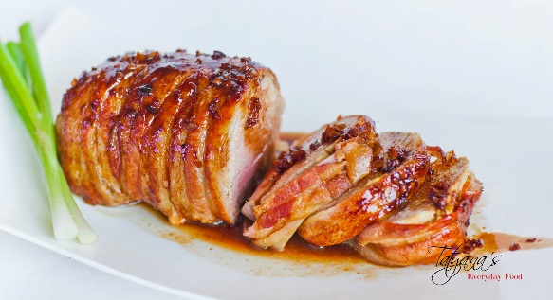**with Garlic Mashed Potatoes, Coleslaw & Dinner Roll**

**$ 7.00**

**LUNCH ORDER FORM**

Date: THURSDAY 5/2/19

Name: ___________________________________________________

|  |  |
| --- | --- |
| **Special $7.00** | **Pick up OR Delivery** |
| * **Garlic Mashed Potatoes** * **Coleslaw** * **Dinner Roll** | What lunch is it needed for (time):   * 1st Lunch: 10:08 * 2nd Lunch: 10:43 * 3rd Lunch: 11:18 * Other: ________________ |

*\*\*\*Please return to us ASAP by email or in The Tiger Terrace mailbox.*

*Please have all orders turned into The Tiger Terrace by Friday 4/26/19 9:00 a.m.*