**MONTHLY TAKE HOME MEAL !!!!!!**

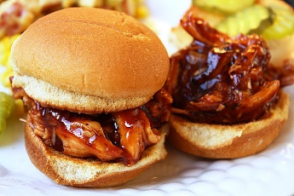  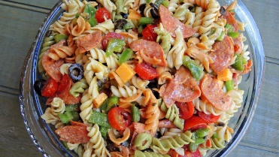

**May 16, 2019**

PULLED PORK SANDWICH, PASTA SALAD or COLESLAW

SPICED CORN, DESSERT

PLEASE CIRCLE PASTA SALAD OR COLESLAW

Family of 2 - $10.00

Family of 4 - $20.00

Name: __________________________________________

2 – Person _______________________________________

4 – Person _______________________________________

**All orders must be in by Friday MAY 10TH @ 9:00 A.M.**